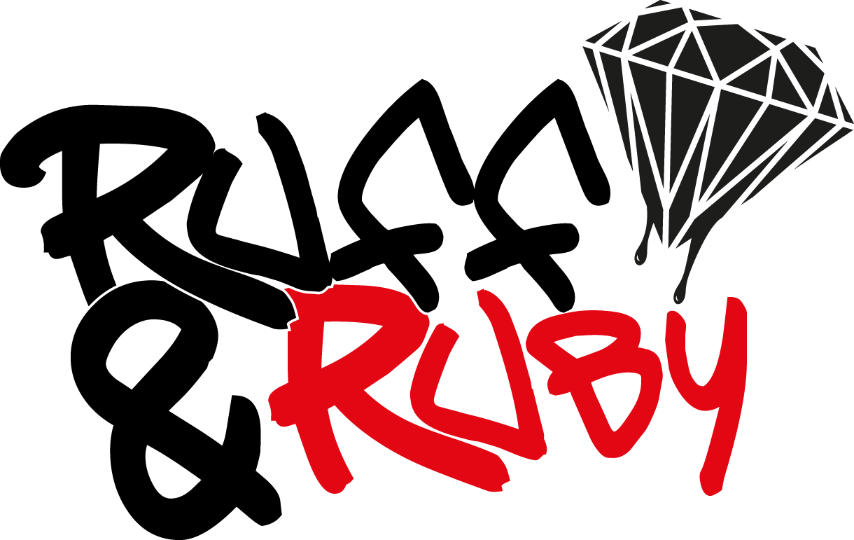

**#PERMISSIONFORM 24/25**

**email:** [**info@ruffandruby.com**](mailto:info@ruffandruby.com) **Web:** [**www.ruffandruby.com**](http://www.ruffandruby.com)

Dear……………………………

As part of the RUFF & RUBY innovative services …………………………………………….has been invited to participate in one of our programs that are run to inspire & engage young people.

The activities / experience can be anything from an inspirational activity or trip, youth project,1:1 mentor / life coaching, workshops session in schools or the community , creative arts session, music studio,supporting a charity event in team or benefitting from a VIP experience .

**If your young person is under 18 years then please complete and sign the permission form below.**

**I (Name) ……………………………………………………..**

**(status) ……………………………………………………… (parent / carer / support worker)**

**give permission for …………………………………………… to take part** in the RUFF & RUBY activities / experiences in various locations, during school time where appropriate, or after school / evenings / weekends.

**I DO / DO NOT** (please delete as appropriate) give permission for the above to be photographed/filmed during the programs and services we undertake.

**I DO / DO NOT** (please delete as appropriate) give permission for photos/media featuring my child/young person to be used to help promote our work as a charity. Photos/media may be used in publicity materials to help raise awareness of our services, fundraising events and campaigns.

NB. Ruff & Ruby has public liability & indemnity insurance.

**Signed ………………………………………….. Date ……………………………………**

**Ruff & Ruby (Rubygirl featuring Ruff Diamonds)** is a registered charity based in Stoke-on-Trent that works to promote positive self-esteem and aspirations in young people through innovative programs and services.